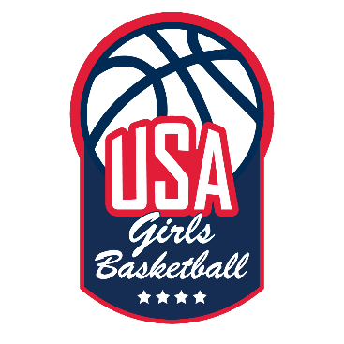
At-Home Training Workout: Create Your Own
Pick 3 or 4 drills you need to improve on and talk to our trainers for any questions!

Warm Up
- Walking
  - High knees
  - Butt kicks
  - Lunges
  - Hamstring kicks
- Full Speed
  - High knees
  - Butt kicks
  - 50% jog
  - 75% jog
  - 100% run
Ball Handling
- 50 reps R Hand / L Hand
  - Toes
  - Knees
  - Hips
  - Shoulders
- Stationary
  - Vdribble
  - Vdribble cross
  - Vdribble cross/cross
  - Vdribble rocker
  - Vdribble rocker/between
  - Vdribble float, cross
  - Vribble cross/between
- Cross step footwork
  - Repeat above
- Small steps forward
  - Repeat above
Transition Finishes
- Attack up sideline (cruise control)
  - Layup finishes
    - In front of defense
    - 1-2 step with defender on hip
    - Slam on breaks
  - Make a move at the three point line into layup
    - Vdribble variations
    - Float ball variations (between, cross, rocker)
  - Make a move at three point line into secondary defender move
    - Spin finish
    - Shotfake, spin finish
    - Shotfake spin step through

- Cone finishes – need two players
  - Layups
  - Jumpers
  - Misdirection
  - Play it out
Back to Basket Moves
- Catch immediately, spin over L shoulder/R shoulder
- Catch shimmy to L and spin over R shoulder
- Drop step R/L hand
- Catch face up, crab dribble finish middle of rim
- Catch face up, crab dribble spin and finish
Walk Up Explode Jumpers
- V dribble variations
  - Add hesitations after different moves
- Between the legs float
- V dribble float
  - Variations – cross, between, etc.
- Pocket to push cross
- Pocket to cross
Pick and Roll
*KEY TO EXECUTION IS MAKING MOVE TO SHIFT DEFENDER TOWARDS BASELINE
- Snake
  - Combo moves
  - Read a gap
  - Pocket pass to post
- Use it
  - Jumpers
  - Change of direction move
- Refuse it
  - Jumpers
  - Change of direction move
- Use/Reuse

Patience
- Jab/quarterstep/circle over head/opposite hip/rip and attack
- Jab/quarterstep
- Forward jab
  - Force closeout attack high foot

Shooting off Dribble
*50 reps simulate footwork into gather off dribble – NO BALL
- R hand dribble
- L hand dribble

*50 reps simulate with basketball into shot
- R hand dribble
- L hand dribble

Burnout Shooting

- 12 ft 1 dribble jumpers R hand dribble – 10 makes 5 spots
- 15 ft 1 dribble jumpers R hand dribble – 10 makes 5 spots
- 12 ft 1 dribble jumpers L hand dribble – 10 makes 5 spots
- 15 ft 1 dribble jumpers L hand dribble – 10 makes 5 spots

